**MTech Thesis Project**

**Understanding the trans-translation process**

**of *Leptospira interrogans***



Submitted for the partial fulfilment of requirement

for the award of the degree of Master of Technology from IIT Guwahati

Under the supervision of

**Prof. Manish Kumar**

Submitted by

**Satarupa Deb Sinha**

234111008

Department of Biosciences and Bioengineering

Indian Institute of Technology Guwahati

Guwahati, Assam-781039, India

2nd May, 2025

**Certificate**

This is to certify that the thesis entitled "**Understanding the trans-translation process of *Leptospira interrogans,***" submitted by **Satarupa Deb Sinha** in fulfillment of the degree **Master of Technology Biotechnology**, is a Bonafide record of the work carried out by her under the guidance of **Prof. Manish Kumar** at the **Department of Biosciences and Bioengineering, Indian Institute of Technology, Guwahati**. This study has not been submitted elsewhere for a degree.

**Signature of student:**

Date: 02-05-2025

Place: IIT Guwahati

**Signature of supervisor:**

Date: 02-05-2025

Place: IIT Guwahati

Satarupa Deb Sinha 234111008

MTech 2nd year (Bioengineering) IIT Guwahati, Assam, India

Dr. Manish Kumar Professor Department of BSBE

IIT Guwahati, Assam, India

**Signature of HOD:**

Date:02-05-25 Head of Department

Place: IIT Guwahati

Department of BSBE

IIT Guwahati, Assam, India

**Statement**

I do hereby declare that the work presented in the thesis entitled "**Understanding the trans-translation process of *Leptospira interrogans*** " is the result of an investigation carried out by me in the **Department of Biosciences and Bioengineering, Indian Institute of Technology, Guwahati, India,** under the guidance of Dr. Manish Kumar. In keeping with the general practice of reporting scientific observations, due acknowledgment has been made wherever the work described is based on the findings of other investigators.

Signature of student:

Date: 02-05-2025

Place: IIT Guwahati

Satarupa Deb Sinha

234111008

MTech 2nd year (Bioengineering)

IIT Guwahati, Assam, India

Acknowledgment

I am thankful to my MTP supervisor, Dr. Manish Kumar (Professor, Department of Biosciences and Bioengineering), for giving me this opportunity to pursue my Master's research work under his supervision in his laboratory. His valuable guidance, support, and cooperation helped me to complete my Master's thesis project.

I am also thankful to my review committee members, Dr. Shankar Prasad Kanaujia, Dr. Subrata Pramanik, and Dr. Biman B Mandal. I owe my thanks to the Department of Biosciences and Bioengineering, Indian Institute of Technology Guwahati, for providing facilities to pursue my research.

I would also like to express my gratitude to all the lab members, who supported me technically and encouraged me throughout my research work.

Finally, I thank my parents for their endless support and faith in me. This accomplishment would not have been possible without them.

Signature:

Satarupa Deb Sinha

Abstract

*Leptospira interrogans* is a pathogenic spirochete responsible for leptospirosis, a re-emerging zoonotic disease with significant global health impact. This bacterium infects a wide range of vertebrate hosts, including humans, causing manifestations ranging from mild flu-like symptoms to severe complications such as Weil's disease and severe pulmonary hemorrhagic syndrome. Protein synthesis accuracy and quality control are critical for bacterial survival, particularly under stress conditions.

This study focuses on the trans-translation mechanism, a bacterial ribosome-associated quality control pathway involving transfer-messenger RNA (tmRNA) and small protein B (SmpB). Trans-translation rescues stalled ribosomes on truncated mRNAs, tagging incomplete polypeptides for degradation and maintaining proteome integrity. The research investigates the molecular details of trans-translation in *L. interrogans*, aiming to elucidate its role in pathogenesis and potential as a therapeutic target. Understanding this quality control system can provide insights into the bacterial adaptive mechanisms and guide the development of novel antimicrobial strategies against leptospirosis.

Table of Contents

1 Introduction 8

1.1 Leptospirosis 8

1.2 Trans-Translation Mechanism 9

1.1.1. Recognition of Peptide Tails (tmRNA Binding) 10

1.1.2. tmRNA Binding to the Ribosome 10

1.1.3. Peptide Tag Addition 11

1.1.4. Release of Incomplete Protein 11

1.1.5. Ribosome Recycling 11

1.1.6. Degradation of the Incomplete Protein 11

2 Literature Review 12

2.1 *Leptospira interrogans:* the organism of research interest 12

2.2 Ribosome-Associated Quality Control in Bacteria 12

2.3 Structure of tmRNA 13

2.4 Small protein B (SmpB) 14

2.5 Utilization of Superfolder GFP (sfGFP) in Studying Trans-Translation and Ribosomal Stalling 15

2.6 Aminoacylation of tmRNA 17

2.7 Importance of 3'CCA Sequence 18

3 Aim and Scope of the proposed work 18

4 Objectives 18

5 Materials and Methods 19

5.1 Bacterial strain and culture media 19

5.2 Vector used in the study 19

5.3 Primer design for cloning *ssrA* gene of *E. coli*  in pTZ57R/T transcription vector: 21

5.4 Preparation for Site-Directed mutagenesis 21

5.5 Primer designing 21

5.6 Plasmid isolation 24

5.7 Plasmid isolation of pAGM22082-sfGFP1-10: 24

5.8 Plasmid isolation of pQE30-his-AlaRS: 24

5.9 Plasmid isolation of pTZ57R/T_LinssrA: 24

5.10 Polymerase Chain Reaction (PCR): 25

5.11 KLD (Kinase-Ligase-DpnI) reaction 25

5.12 Competent cell preparation: 25

5.13 Transformation of mutated plasmid: 26

5.14 Agarose gel electrophoresis 26

5.15 Polymerase Chain Reaction (PCR) of LinssrA gene amplification: 26

5.16 PCR Clean-up of insert: 27

5.17 Restriction endonuclease digestion: 27

5.18 Gel extraction: 28

5.19 Ligation of double-digested insert and vector: 28

5.20 Transformation of ligated product: 28

5.21 Protein Purification 28

6 Results and Discussion 30

6.1 Cloning of *ssrA* gene of *E. coli* in pTZ57R/T transcription vector 30

6.2 Overexpression and purification of AlaRS protein in *E. coli* JM109 30

6.3 Purification of LinSmpB protein 31

6.4 Sanger Sequencing Verification of mutated pTZ57R/T_LinssrA 32

6.5 Re-cloning of *ssrA* gene of *L. interrogans* in vector pTZ57R/T 34

7 Conclusion 35

8 References 36

**List of Figures**

**Figure 1**. High-resolution scanning electron micrograph of L. interrogans serovar Copenhageni 9

**Figure 2.** Mechanism of tmRNA-Mediated Trans-Translation in Ribosome Rescue 10

**Figure 3.** Structure of tmRNA (left) Diagram of the secondary structure of Thermus thermophilus tmRNA; (right) 3D molecular model of tmRNA (PDB entry: 3IYQ). 14

**Figure 4.** Structure of SmpB of Thermus thermophilus (PDB entry: 1WJX).[10] 15

**Figure 5.** Charging of tmRNA with alanine [15] 17

**Figure 6.** Map of the pTZ57R/T cloning vector. Unique restriction sites are indicated 20

**Figure 7.** DNA Sequence of MCS Region 20

**Figure 8.** Diagrammatic representation of generating tmRNAGFP11 22

**Figure 9. (A) Agarose Gel Electrophoresis (1.5% gel) of PCR Amplicon:** Amplification of ssrA gene of E. coli from its genomic DNA **(B) Restriction digestion of cloning transcription vector pTZ57R/T:** Digested pTZ57R/T_CRISPR_sense run on 1.5% agarose gel.  **(C) Clone confirmation by culture PCR:** 1.5% Agarose gel analysis of clones obtained from culture PCR from transformed colonies of E. coli DH5α with pTZ57R/T-EcossrA plasmid. 29

**Figure 10. Overexpressing of AlaRS:** Coomassie Blue stained 10% SDS-PAGE showing the resolved protein lysates of E. coli JM109 cells after induction with (+) and without (-) IPTG (1 mM). 30

**Figure 11. Purification of AlaRS protein using Ni+2-NTA affinity chromatography:** 10% SDS-PAGE analysis of elutes (1-5) stained with Coomassie Brilliant Blue showing the presence of 98 kDa band that corresponds to AlaRS protein. 30

**Figure 12. Purification of SmpB protein using Ni+2-NTA affinity chromatography:** 12% SDS-PAGE analysis of elutes (1-5) stained with Coomassie Brilliant Blue showing the presence of 18 kDa band that corresponds to SmpB protein. 31

**Figure 13.** Pairwise alignment of Sanger sequencing result with the reference LinssrA gene sequence. 32

**Figure 14**. **Further confirmation of false mutation** by **(A)** restriction digestion: Digested pTZ57R/T_LinssrA run on 1.0% agarose gel. **(B)** Culture PCR and Plasmid PCR: Plasmid pTZ57R/T_LinssrA and culture containing the plasmid was amplified along with genomic DNA of L. interrogans. 32

**Figure 15**. **Cloning confirmation of ssrA gene of L. interrogans (A) culture PCR:** 1.5% Agarose gel analysis of clones obtained from culture PCR from transformed colonies of E. coli DH5α with pTZ57R/T-LinssrA plasmid. **(B) Plasmid PCR:** Further, clone confirmation by plasmid PCR. 33

List of Tables

**Table 1.** Primer designed for ssrA gene of *E. coli*. 22

**Table 2.** Primer designed for replacing MLD region of ssrA gene of *E. coli*. 22

**Table 3.** Primer designed for replacing MLD region of ssrA gene of *L. interrogans*. 23

**Table 4.** Primers designed to generate CCA-3’ end in Lin-ssrA 23

**Table 5:** PCR cycle for site directed mutagenesis of MLD region of LinssrA 26

**Table 6:** PCR cycle for LinssrA gene amplification 28

List of abbreviations

**AlaRS –** alanyl tRNA synthetase

**bp**- Base pair

**DNA**- Deoxyribonucleic acid

**ds-DNA**- Double-stranded DNA

**EDTA**- Ethylenediaminetetraacetic acid

**EtBr**- Ethidium bromide

**IPTG**- Isopropyl β-D-1-thiogalactopyranoside

**kb-** Kilobase

**kDa-** Kilo Dalton

**LB medium-** Luria Bertani medium

**LinSmpB**- *Leptospira interrogans* SmpB

**NFW-** Nuclease free water

**Ni2+ -NTA**- Nickel-nitrilotriacetic acid

**nt**- Nucleotide

**PAGE**- Polyacrylamide gel electrophoresis

**PBS**- Phosphate-buffered saline

**PCR**- Polymerase chain reaction

**tmRNA**- Transfer-messenger RNA

**rpm**- Revolution per minute

**RNA-** Ribonucleic acid

**rSmpB**- Recombinant SmpB protein

**SDS-** Sodium dodecyl sulphate

**SmpB** - Small Protein B

**TAE buffer-** Tris-acetate-EDTA buffer

**UV-** Ultraviolet light

Understanding trans-translation process

of Leptospira interrogans

# Introduction

## Leptospirosis

Leptospirosis is one of the most overlooked zoonotic, waterborne infectious diseases, caused by a diverse group of spirochetes from the genus *Leptospira*.[1] Each year, the disease affects over one million people and leads to nearly 60,000 deaths. In animals, leptospirosis can lead to reduced milk production in cattle and reproductive issues like infertility in domestic species.

Humans do not have a specific serovar adapted to them; instead, they contract the disease directly from animals through contact with urine or tissues, or indirectly via contaminated water. The main environments that pose transmission risks include water, rodent habitats, and areas with livestock or pets. While leptospirosis can occur worldwide, it is more prevalent in humid tropical regions, particularly where sanitation is poor and rat populations are high.[11] The risk of infection increases with exposure to natural water bodies, especially during rainy seasons or floods. The disease affects individuals in high-risk groups who come into contact with animal reservoirs or contaminated environments. [8]

Leptospirosis is caused by spirochetes from the genus Leptospira, which includes 20 species divided into three clusters: 9 pathogenic, 6 saprophytic, and 5 intermediate. The pathogenic and intermediate species are responsible for the disease, encompassing over 260 serovars, and will be referred to as parasitic Leptospira in this text. These organisms are thin spirochetes, measuring 0.1 to 0.2 µm in diameter and 6 to 12 µm in length, allowing them to pass through 0.45 µm filters. They exhibit significant motility, moving about 20 µm in 2 to 3 seconds in typical media. [1,2]

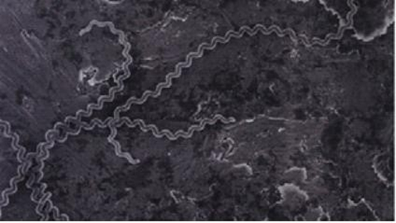

**Figure 1**. High-resolution scanning electron micrograph of L. interrogans serovar Copenhageni[1]

In humans, the disease may initially present with flu-like symptoms but can escalate to multi-organ failure, potentially resulting in death. Several factors contribute to the virulence of *Leptospira*, with RNA playing a crucial role in regulatory mechanisms. One such RNA is tmRNA, which, along with the associated protein SmpB, plays a part in trans-translation. This process rescues stalled ribosomes from truncated mRNA, tagging incomplete polypeptide chains with an SsrA tag. These tagged proteins are then degraded by proteases such as ClpXP and ClpAP.

## Trans-Translation Mechanism

Trans-translation is an essential mechanism in bacteria that plays a vital role in various quality control pathways, ensuring proteins are synthesized accurately despite challenges like transcription errors, mRNA damage, and translational frameshifting. This process involves a ribonucleoprotein complex made up of tmRNA, which possesses features of both tRNA and mRNA, and the small protein SmpB.[17]

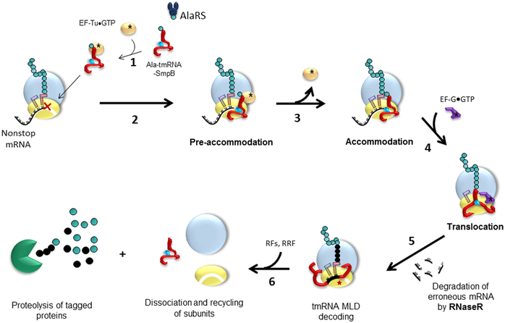

**Figure 2.** Mechanism of tmRNA-Mediated Trans-Translation in Ribosome Rescue

### Recognition of Peptide Tails (tmRNA Binding)

Trans-translation begins when ribosomes stall on a truncated mRNA or at a problematic stop codon. A small RNA molecule known as tmRNA (transfer-messenger RNA) recognizes the stalled ribosome. The tmRNA has a dual function: it acts as both a tRNA and mRNA, allowing it to rescue the stalled ribosome by providing a template for the addition of a peptide tag to the incomplete protein.[6]

### tmRNA Binding to the Ribosome

The tmRNA binds to the ribosome at the A-site. It mimics the structure of tRNA, allowing the ribosome to accept it and read its coding sequence. The tmRNA consists of two functional domains: an mRNA-like domain that encodes a tag, and a tRNA-like domain that carries an alanine residue, which is added to the nascent polypeptide chain.

### Peptide Tag Addition

The ribosome reads the mRNA-like domain of the tmRNA, effectively translating the sequence into an alanine-containing peptide. This process replaces the stalled translation and ensures that the incomplete protein receives a degradation tag, often known as the "ssrA tag" or "tm-tag". The ribosome continues to translate this sequence until it reaches a stop codon in the tmRNA.[16]

### Release of Incomplete Protein

After the ribosome finishes translating the tag sequence encoded in the tmRNA, it encounters a stop codon. The release factor (RF) then catalyzes the termination of translation, releasing the incomplete protein with the attached tag. This tag usually marks the protein for degradation by the cellular proteases, specifically the ClpXP protease complex.[19]

### Ribosome Recycling

Following the release of the tagged incomplete protein, the ribosome is recycled. The ribosome disassociates from the mRNA and tmRNA, and the tmRNA is free to interact with new ribosomes on other stalled mRNAs. This allows the cell to continue translating other messages efficiently.

### Degradation of the Incomplete Protein

The peptide tag added to the truncated protein during trans-translation typically signals the protein for degradation. Proteins tagged in this way are recognized by protease complexes like ClpXP or Lon protease, which degrade the incomplete, potentially harmful proteins, ensuring cellular quality control.

Trans-translation is essential for rescuing stalled ribosomes and preventing the accumulation of incomplete proteins, maintaining protein quality control in cells, especially under stressful conditions or in the presence of faulty transcripts.

# Literature Review

## *Leptospira interrogans:* the organism of research interest

***Leptospira interrogans*** is a pathogenic spirochete bacterium that causes leptospirosis, a re-emerging zoonotic disease. This organism can infect a wide range of vertebrate hosts, including humans, who are particularly susceptible.

*Leptospira interrogans* is a thin, spiral-shaped, highly motile bacterium characterized by distinctive hooked ends. These millimeter-long pathogens are responsible for leptospirosis, a significant zoonotic disease with global prevalence. The bacterium can infect humans and various animals, with rodents, particularly brown rats, serving as the primary reservoirs. Brown rats harbor the bacteria in their renal tubules and excrete them through urine, which is a major source of human infection. Transmission occurs through direct or indirect contact with contaminated urine from carrier animals, such as pigs, dogs, horses, and cattle.[13]

Clinical manifestations in humans range from non-specific symptoms like fever, muscle pain, mild flu-like symptoms to severe complications such as Weil's disease, characterized by multiorgan failure, jaundice, acute kidney injury, lung hemorrhages, and severe pulmonary hemorrhagic syndrome (SPHS). SPHS, increasingly recognized as a critical complication of leptospirosis, is a significant prognostic factor associated with high mortality in severe cases.[9]

## Ribosome-Associated Quality Control in Bacteria

Protein synthesis, also known as translation, is a crucial biological process that takes place on ribonucleoprotein complexes called ribosomes. The initiation of protein synthesis begins when ribosomes identify the start codon on messenger RNA (mRNA), typically the AUG codon, with GUG or UUG being fewer common alternatives. Following this initiation, ribosomes undergo several elongation cycles, during which they traverse the open reading frame of the mRNA—this segment encodes a specific protein—decoding its nucleotide sequence and translating it into the corresponding amino acid sequence of the protein being synthesized. Each cycle of elongation starts with the arrival of the appropriate aminoacyl tRNA at the ribosomal A site, where it interacts with the peptidyl tRNA in the P site. This process culminates in the translocation of the newly formed peptidyl tRNA from the A site to the P site. Ultimately, translation concludes when the ribosome encounters one of the three stop codons (UAA, UAG, or UGA), leading to the release of the fully formed protein. The entire elongation cycle and its key components are illustrated in the accompanying figures.[23]

Translation is one of the most energy-intensive processes within an organism and typically proceeds without issues. However, various factors can cause ribosomes to stall during translation. One significant threat to this process is ribosomal arrest on truncated mRNAs, which occurs when a ribosome reaches the 3' end of an incomplete mRNA that lacks a stop codon. This situation prevents the termination of translation and the subsequent release of the ribosome. If ribosomes become stalled and accumulate within the cell, it can lead to a rapid depletion of the ribosomal pool, ultimately resulting in cell death. To address this challenge, bacterial cells have evolved three well-defined ribosome rescue pathways: tmRNA, ArfA, and ArfB. These pathways facilitate the recovery of stalled ribosomes, allowing for the release of incomplete peptides and the recycling of ribosomes for additional rounds of translation. It is estimated that in *E. coli*, 2-4% of translation events are subject to ribosome rescue mechanisms, even under normal growth conditions. Among these pathways, trans-translation is the primary mechanism for ribosome recycling, mediated by a specialized RNA molecule known as transfer-messenger RNA (tmRNA), also referred to as 10S RNA or small stable RNA (ssrA).[23]

The RNA-binding protein SmpB plays a critical role in this process by specifically interacting with tmRNA. It is integral to the translational quality control system, as it recognizes and binds to ribosomes that have stalled. The tmRNA then adds a peptide tag to the nascent, partially synthesized protein chain, marking it for degradation by C-terminal cellular proteases such as ClpXP and ClpAP.[19]

## Structure of tmRNA

Transfer messenger RNA (tmRNA), also referred to as 10Sa RNA or SsrA RNA, serves dual functions as both a transfer RNA and a messenger RNA.[18] These tmRNAs are chimeric RNA molecules, typically ranging from 260 to 420 nucleotides in length, with specific lengths of 363 nucleotides [5] in *Escherichia coli* and 348 nucleotides in *L. interrogans* [26]. The ssrA gene, responsible for encoding tmRNA, is present in nearly all bacterial genomes. It is estimated that each bacterial cell contains approximately 500 to 700 tmRNA molecules, which constitutes about 5% of the total ribosome count, based on the ratio of tmRNA to 5S ribosomal RNA.[20] The predicted secondary structure of tmRNA includes a tRNA-like domain (TLD), an open reading frame (MLD), and four pseudoknots (PK1, PK2, PK3, and PK4). The TLD resembles the structure of alanine tRNAs, featuring a T-loop, D-loop, and an aminoacyl acceptor stem. The MLD, or mRNA-like domain, encodes a protein tag consisting of 11 amino acids in *E. coli*, which acts as a degradation signal when attached to any protein.

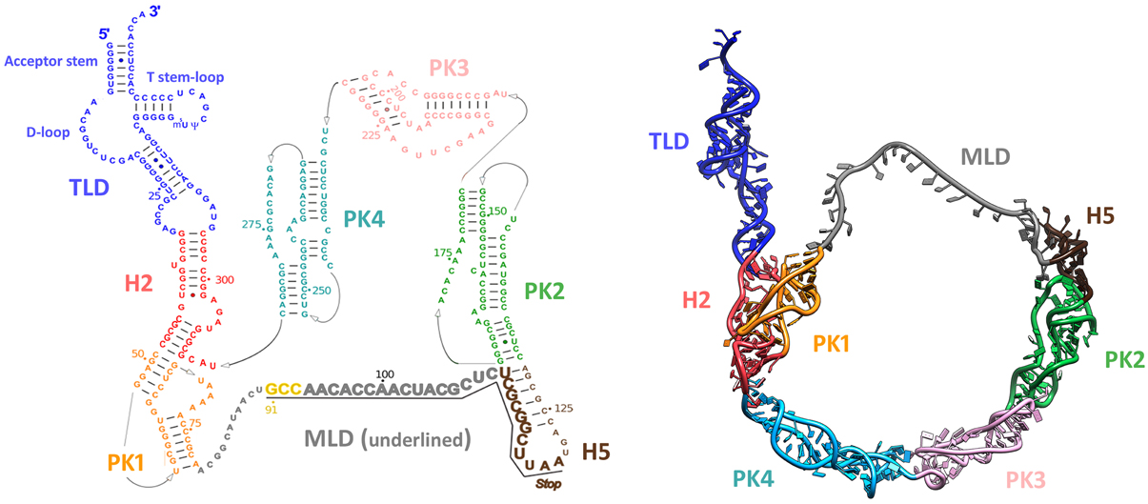

**Figure 3.** Structure of tmRNA (left) Diagram of the secondary structure of Thermus thermophilus tmRNA; (right) 3D molecular model of tmRNA (PDB entry: 3IYQ).[16]

## Small protein B (SmpB)

Small protein B (SmpB) is a small protein consisting of 160 amino acids in both Escherichia coli and L. interrogans, encoded by the smpB gene. SmpB exhibits a high affinity for tmRNA and serves as its primary partner during the ribosome rescue process. It is essential for the stable binding of tmRNA to 70S ribosomes. Nuclear magnetic resonance (NMR) studies conducted on Thermus thermophilus have shown that SmpB interacts with tmRNA via an oligonucleotide-binding fold (OB-fold) motif, which is characterized by six antiparallel β-strands arranged in a closed β-barrel structure, surrounded by three α-helices. The C-terminal tail of SmpB remains unstructured in solution but adopts a fourth α-helix upon insertion into the ribosome. Additionally, the central loop of SmpB is disordered in the crystal structure. When SmpB is complexed with tmRNA, it forms a structure that closely resembles alanyl tRNA, facilitating the trans-translation mechanism involved in ribosome rescue.[7]

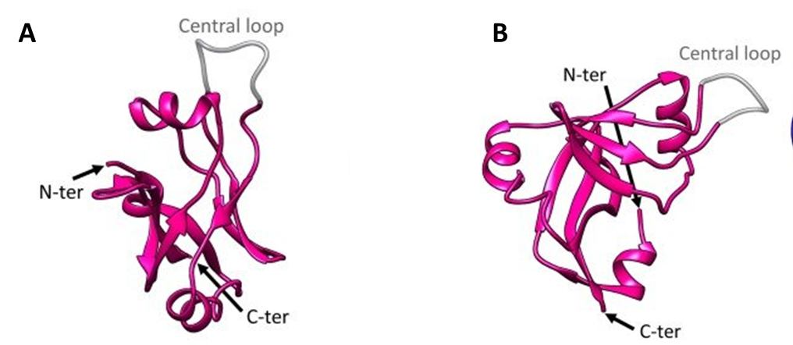

**Figure 4.** Structure of SmpB of Thermus thermophilus (PDB entry: 1WJX).[10]

## Utilization of Superfolder GFP (sfGFP) in Studying Trans-Translation and Ribosomal Stalling

In the study of trans-translation, sfGFP has been a widely used reporter for assessing the fate of stalled ribosomes and tagged proteins. Fusions of sfGFP with various peptide tags allow for real-time monitoring of protein synthesis and degradation within live bacterial cells. Superfolder GFP (sfGFP) is a variant of the Green Fluorescent Protein (GFP) engineered for improved folding kinetics and stability. It folds efficiently even when fused to poorly folding peptides or proteins, making it a valuable tool in studying protein expression, folding, and interactions in living cells.[3,4] In the context of trans-translation, sfGFP is frequently used in reporter assays, where it allows visualization and quantification of protein synthesis and degradation processes, especially in bacteria like *Escherichia coli* and pathogens. [21,22]

In 1999 Roche and Sauer et al. utilized a GFP variant in the context of trans-translation. They demonstrated how tagged proteins could be visualized using fluorescence, providing a proof-of-concept for using fluorescent reporters like sfGFP in more sophisticated bacterial studies.

In 2008 Buskirk et al. pioneered the use of superfolder GFP in trans-translation systems by fusing sfGFP to proteins undergoing tmRNA-mediated tagging in *E. coli*. It helped elucidate the role of trans-translation in maintaining protein quality control, especially under stress conditions that induce ribosomal stalling.

Guyomar et al. (2020) utilized the engineered superfolder green fluorescent protein (sfGFP) as a fluorescent reporter to investigate the trans-translation mechanism, a critical process for rescuing stalled ribosomes in bacterial translation. By constructing a modified tmRNA variant, tmRNAGFP11, which incorporates the sfGFP11 domain, the researchers established an in vitro system that allows for the reassembly of sfGFP when trans-translation is active. This innovative approach enabled the quantification of trans-translation activity through fluorescence, facilitating high-throughput screening for potential inhibitors of this process. The results demonstrated that the presence of tmRNAGFP11 significantly enhanced the fluorescent signal, confirming the efficiency of the trans-translation system and its potential utility in antibiotic discovery aimed at targeting ribosome stalling in pathogenic bacteria.[12]

Thepaut et al.,2023 used **superfolder GFP (sfGFP)** as a reporter to study trans-translation by monitoring GFP reassembly during the process. sfGFP, known for its efficient folding even with poorly folding peptides, was fused to proteins involved in tmRNA-mediated tagging. When trans-translation rescued stalled ribosomes, sfGFP reassembled and fluoresced, providing a real-time indicator of activity. This approach enabled the development of a **cell-free assay** for rapid evaluation of trans-translation in **ESKAPE bacteria**. The assay was designed for high-throughput screening of antimicrobial compounds and to investigate the mechanisms of trans-translation in pathogenic bacteria.[24]

## Aminoacylation of tmRNA

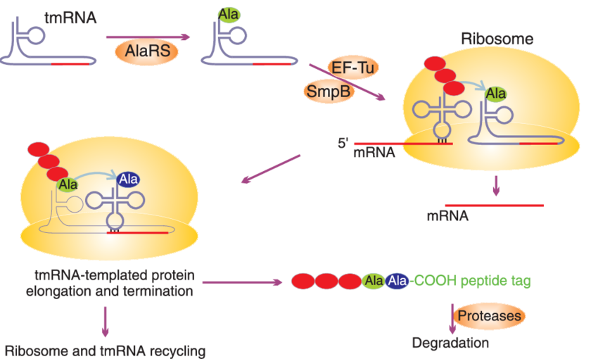

**Figure 5.** Charging of tmRNA with alanine [15]

The conserved 3′-terminal tail of tmRNA is always charged with an alanine by **alanyl-tRNA synthetase (AlaRS)**, a class II tRNA synthetase that catalyzes the esterification of alanine to tRNAAla (Bessho et al., 2007). The 3′-terminal tail of tmRNA is structurally similar to that of tRNAAla, allowing it to be charged with alanine by AlaRS. The G3-U70 wobble base pair is a critical structural feature found in the acceptor stem of all tRNAAla isoacceptors. This base pair is essential for the specific recognition of tRNAAla by AlaRS. Interestingly, this same wobble base pair is conserved in all ssrA sequences, which encode tmRNA. This conservation suggests that tmRNA mimics the structure of tRNAAla to be recognized and charged by AlaRS. The presence of an adenosine at the discriminator position, adjacent to the 3′-terminal CCA, further aids in the specific recognition of tRNAAla by AlaRS. This structural feature is also likely conserved in tmRNA, contributing to its recognition by AlaRS (Hou and Schimmel, 1988). AlaRS is a class II tRNA synthetase that specifically catalyzes the esterification of alanine to tRNAAla. Its ability to recognize the conserved structural features of tmRNA makes it the only aminoacyl-tRNA synthetase that charges tmRNA with alanine in vivo.

## Importance of 3'CCA Sequence

The amino acid attachment site at the 3′ terminus of all mature tRNAs has a universally conserved CCA sequence. This sequence is essential for the function of tRNAs as it provides the site where amino acids are linked to form aminoacyl-tRNAs, which are then used in the translation process by the ribosome to synthesize proteins. Interestingly, despite its importance, the CCA sequence is not encoded directly by most tRNA genes in eukaryotes, archaea, and bacteria. Instead, tRNA genes typically end with a different sequence, and the CCA sequence is added after the tRNA has been transcribed. This addition is carried out by a specialized enzyme known as the **CCA-adding enzyme**, or **tRNA nucleotidyl transferase**.[25] This enzyme is essential for tRNA maturation. It catalyzes the post-transcriptional addition of the CCA sequence to the 3′ end of the tRNA molecule. The enzyme uses ATP (adenosine triphosphate) to add the C and A nucleotides, and CTP (cytidine triphosphate) to add the final C nucleotide. This process ensures that all tRNAs, regardless of their original genetic sequence, end with the required CCA sequence, enabling them to fulfill their role in protein synthesis.[14]

# Aim and Scope of the proposed work

To study the role of tmRNA and its associated protein SmpB in *L. interrogans* serovar Copenhageni Fiocruz L1-30, particularly in rescuing stalled ribosomes and degrading tagged proteins based on green fluorescent protein (GFP) reassembly with the help of an invitro assay.

# Objectives

1. Replacing MLD region of *ssrA* gene (by Site-Directed Mutagenesis) of -
   * *Leptospira interrogans*
   * *E. coli*
2. Production of LintmRNAGFP11 of (by in vitro transcription) -
   * *Leptospira interrogans*
   * *E. coli*
3. Overexpression and purification of His-AlaRS protein from pQE30 plasmid
4. Cloning of *ssrA* gene of *E.coli* in pTZ57R/T vector (AmpR) between *HindIII* and *KpnI*
5. Binding of LinSmpB with – (i) tmRNA of *E.coli* & (ii) tmRNA of *L. interrogans*
6. In vitro trans-translation assay

# Materials and Methods

## Bacterial strain and culture media

The strains of *E. coli* used were DH5α, and BL21 (DE3), obtained from the Indian Veterinary Research Institute (IVRI), Izatnagar, Bareilly, Uttar Pradesh, and JM109, obtained from Addgene as a bacterial stab culture. They were cultured in Luria Bertani (LB) broth or agar as required, grown at 37 ºC overnight at 180 rpm.

## Vector used in the study

Expression vector pQE30 (Addgene) was utilized to express N-terminal 6-his-tagged protein AlaRS. The selectable marker is ampicillin, and gene expression is regulated by the T5 promoter. A stock solution of Ampicillin (100 mg/ml) was prepared with a working concentration of 100 μg/ml. All solutions and supplements used for *E. coli* were autoclaved for 20 minutes at 121 ºC or filter-sterilized.

Expression vector pAGM22082_sfGFP1-10 (Addgene) was used to be served as DNA template for in vitro trans-translation assay. The selectable marker is Kanamycin and gene expression is regulated by the T7 promoter. A stock solution of Kanamycin (100 mg/ml) was prepared with a working concentration of 100 μg/ml. All solutions and supplements used for *E. coli* were autoclaved for 20 minutes at 121 ºC or filter-sterilized.

Transcription vector pTZ57R/T was employed to perform site-directed mutagenesis and clone PCR amplified DNA fragments. The selectable marker is ampicillin, and gene expression is also under the control of the T7 promoter. These promoters facilitate in vitro transcription of the cloned insert, which is beneficial for RNA synthesis.

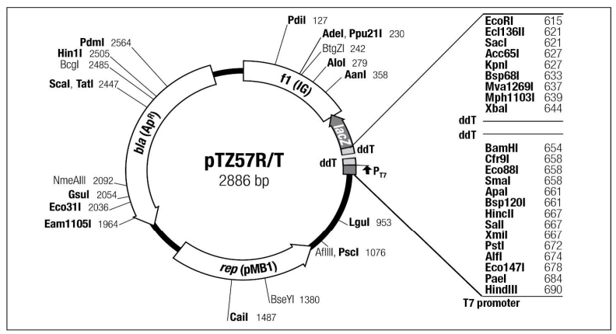

**Figure 6.** Map of the pTZ57R/T cloning vector. Unique restriction sites are indicated

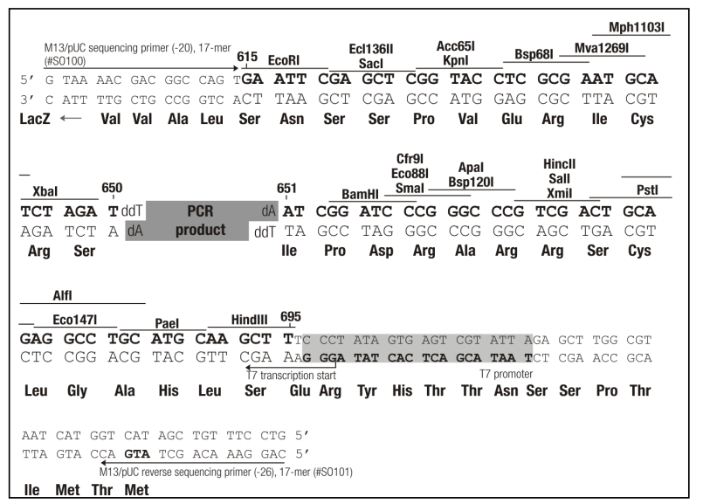

**Figure 7.** DNA Sequence of MCS Region

## Primer design for cloning *ssrA* gene of *E. coli* in pTZ57R/T transcription vector:

Primer designing was done using Thermofisher Scientific OligoPerfect. Restriction sites for enzymes *HindIII* and *KpnI* were added to the sequence of forward and reverse primer of *ssrA* gene.

**Table 1.** Primer designed for ssrA gene of E. coli.

|  |  |  |  |
| --- | --- | --- | --- |
| **Primer** | **Sequence** | **Length** | **Melting temperature**  **(Tm)** |
| Forward | *EcossrA*_*Hind*III_*F*  5’ **CCC***AAGCTT*GGGGCTGATTCTGGATTCGA 3 | 29  bases | 59 °C |
| Reverse | *EcossrA*_*Kpn*I_*R*  5’**CGG***GGTACC*TGGTGGAGCTGGCGGGAGTTG -3' | 30  bases | 67 °C |

Sitting sequence are shown in bold and restriction enzyme sites is shown in italics.

## Preparation for Site-Directed mutagenesis

## Primer designing

Primer designing was done using NEBaseChanger by New England BioLabs.

**Table 2.** Primer designed for replacing MLD region of ssrA gene of E. coli.

|  |  |  |  |
| --- | --- | --- | --- |
| **Primer** | **Sequence** | **Length** | **Melting temperature**  **(Tm)** |
| Forward | 5'TACGTAAATGCTGCTGGGATTACATAATAATAACCTGCTTAGAGC 3' | 45  bases | 56°C |
| Reverse | 5'CTCATGAAGGACCATGTGGTCACGTGCGACTATTTTTTGCGGCTTTTTAC 3' | 50  bases | 61 °C |

**Table 3.** Primer designed for replacing MLD region of ssrA gene of L. interrogans.

|  |  |  |  |
| --- | --- | --- | --- |
| **Primer** | **Sequence** | **Length** | **Annealing temperature**  **(Tm)** |
| Forward | 5’TACGTAAATGCTGCTGGGATTACATAATAATCTCTGCTACGGAAC 3’ | 45  bases | 59 °C |
| Reverse | 5’CTCATGAAGGACCATGTGGTCACGTGCGGTTATTGTTTGAAGGTTTTTAG 3’ | 50  bases | 59 °C |

**Table 4.** Primers designed to generate CCA-3’ end in Lin-ssrA

|  |  |  |  |
| --- | --- | --- | --- |
| **Primer** | **Sequence** | **Length** | **Annealing Temperature (Ta)** |
| Forward | 5’ GCCGTCTCCATATGGGTACCGAGCTCGAATTCACTG 3’ | 36 | 68°C |
| Reverse | 5’ GGGGTTCGAACCCGCGTC 3’ | 18 | 68°C |

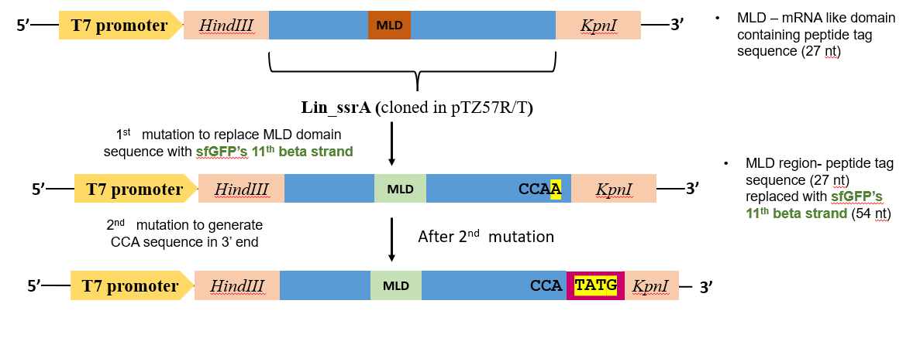

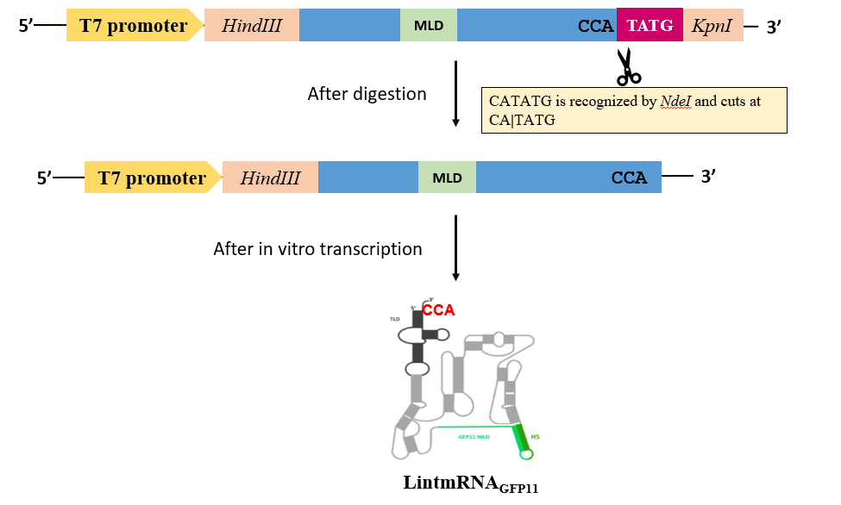

**Figure 8.** Diagrammatic representation of generating tmRNAGFP11

## Plasmid isolation

## Plasmid isolation of pAGM22082-sfGFP1-10:

*E. coli* DH5α cells containing the plasmid pAGM22082_sfGFP1-10 were initially streak plated on an agar plate containing Kanamycin and grown overnight from a single colony. The culture was then stored as a glycerol stock at -80°C, as per the Addgene manual. pAGM22082_sfGFP1-10 - plasmid contains the gene of superfolder GFP with first ten beta strands **lacking stop codon.** For plasmid extraction, 100 µl of the glycerol stock was inoculated into 25 ml of LB broth with Kanamycin and grown overnight. The cells were centrifuged at 5000 rpm for 10 minutes, and the pellet was resuspended in 500 µl of Buffer GSPB1. Buffer GSPB2 was added, and the mixture was gently mixed and incubated for 30 seconds. Buffer GSPB3 was subsequently added to form a precipitate, and the sample was centrifuged at 13,000 rpm for 10 minutes. The supernatant was transferred to a GSure Spin Column, followed by centrifugation at 10,000 rpm for 2 minutes. The flow-through was discarded, and the binding step was repeated three times. The column was washed with Membrane Wash Buffer, and centrifugation was carried out at 13,000 rpm for 3 minutes. Plasmid DNA was eluted using 30 µl of nuclease-free water pre-heated to 65°C, with two elution steps performed. The plasmid DNA was then stored at -20°C to be further used as as template DNA for *in-vito* trans-translation reaction.

## Plasmid isolation of pQE30-his-AlaRS:

*E. coli* JM109 cells containing the plasmid pQE30-his-AlaRS were initially streak plated on an agar plate containing Ampicillin and grown overnight from a single colony. The culture was then stored as a glycerol stock at -80°C, as per the Addgene manual. The plasmid was extracted similar to pAGM22082_sfGFP1-10 using the GSure Plasmid Mini Kit (GCC Biotech).

## Plasmid isolation of pTZ57R/T_LinssrA:

*E. coli* DH5α cells containing the plasmid pTZ57R/T_LinssrA (cloned by a previous student) was also isolated in a similar manner. The antibiotic marker used was Ampicillin (100 µg/ml).

## Polymerase Chain Reaction (PCR):

Polymerase chain reaction of the LinssrA gene was carried out using the GCC Biotech DNA Polymerase Mix Kit. The LinssrA gene was used for site-directed mutagenesis to replace the MLD region with sfGFP's 11th beta strand.

**Table 5:** PCR cycle for site directed mutagenesis of MLD region of LinssrA

|  |  |  |
| --- | --- | --- |
| **Steps** | **Temperature** | **Duration** |
| Initial denaturation | 98 °C | 30 sec |
| Denaturation | 98 °C | 10 sec |
| Annealing | 59 °C | 30 sec/kb |
| Extension | 72 °C | 30 sec |
| Final extension | 72 °C | 2 mins |
| Hold | 4 °C | ∞ |

25 cycles

## KLD (Kinase-Ligase-DpnI) reaction

The KLD (Kinase-Ligase-DpnI) reaction, as part of the Q5 Site-Directed Mutagenesis Kit by New England Biolabs (NEB), was performed (20 mins) to introduce the desired mutation in the DNA. In this reaction, the actions of three enzymes—kinase, ligase, and deoxyribonuclease—were combined. The kinase phosphorylated the 5' ends of the PCR products, enabling ligation, while the ligase covalently joined the complementary strands. The deoxyribonuclease cleaved any remaining non-specific DNA ends, ensuring high specificity for the desired mutation. The KLD reaction was used for efficient and seamless site-directed mutagenesis, facilitating the replacement of specific regions of the gene, such as the insertion of GFP, without the need for additional purification steps or intermediate cloning.

## Competent cell preparation:

The overnight-grown primary culture of *E. coli* DH5α cells was inoculated into 200 ml LB broth and incubated for an hour at 37°C. Then, the culture flask was placed for 30 min on ice. The culture was aliquoted into tubes and centrifuged at 5000 rpm for 10 min at 4 °C. The pellets were resuspended in 100 mM CaCl2, incubated on ice for 1 hour, and then centrifuged at 4000 rpm for 20 min. The cell pellet was resuspended in ice-cold CaCl2 solution and 20% glycerol in 100 mM CaCl2. Competent cells were then aliquoted into tubes and stored at – 80°C.

## Transformation of mutated plasmid:

The uptake of plasmid DNA into competent bacterial cells is brought about by the heat shock method of bacterial transformation. 5 µl of the KLD mix were added to chemically competent *E. coli* DH5α cells. The mixture was incubated on ice for 30 minutes, followed by a heat shock at 42°C for 30 seconds. The cells were then incubated on ice for 10 minutes. 900µl of LB medium were added, and the mixture was gently shaken at 37°C for 1.5 hour. One hundred microliters were spread onto an AmpR plate, which was then incubated overnight at 37°C.

## Agarose gel electrophoresis

The 1X TAE buffer was prepared by diluting 50 X TAE buffer with distilled water. 50X TAE buffer was prepared by dissolving 242 g Tris base, 57.1 ml glacial acetic acid, and 100 ml of 500 mM EDTA (pH 8.0). The appropriate amount of agarose for 1% (w/v) was dissolved in 1X TAE buffer. Ethidium bromide was added to the agarose solution and mixed well. After gel polymerization, it was transferred to an electrophoresis chamber filled with 1X TAE buffer. The DNA samples were mixed with a 6x loading dye containing glycerol (50 %), bromophenol blue (0.2 %), xylene cyanol (0.2 %), and 10 mM EDTA and loaded into the gel wells. The gel was run at 110V for 20 min. Bands were visualized under a UV transilluminator.

## Polymerase Chain Reaction (PCR) of LinssrA gene amplification:

Polymerase chain reaction of the LinssrA gene was carried out GCC Biotech DNA Polymerase Mix Kit.

**Table 6:** PCR cycle for LinssrA gene amplification

30 cycles

|  |  |  |
| --- | --- | --- |
| **Steps** | **Temperature** | **Duration** |
| Initial denaturation | 95 °C | 10 mins |
| Denaturation | 95 °C | 30 sec |
| Annealing | 58 °C | 30 sec |
| Extension | 68 °C | 30 sec |
| Final extension | 68 °C | 10 mins |
| Hold | 4°C | ∞ |

## PCR Clean-up of insert:

PCR clean-up of the insert was done using a QIAquick® PCR purification kit. PCR Clean-up is required to remove the contaminants from PCR products. Five volumes of Buffer PB were added to one volume of the PCR reaction and mixed thoroughly. The mixture was then applied to a QIAquick spin column placed in a collection tube and centrifuged for 30–60 seconds, after which the flow-through was discarded. Next, 750 μL of Buffer PE was added to the column, followed by another centrifugation for 30–60 seconds. The flow-through was again discarded, and the column was centrifuged for an additional minute to remove any residual wash buffer. The QIAquick column was then transferred to a clean 1.5 mL microcentrifuge tube, and 30 μL of nuclease-free water was added directly to the centre of the membrane. After allowing the column to stand for one minute, it was centrifuged for one minute to elute the purified DNA, which was then ready for downstream applications.

## Restriction endonuclease digestion:

Restriction endonucleases cleave the double-stranded DNA within or near the restriction site. Staggered cut by restriction enzyme gives sticky ends, whereas blunt ends are obtained when symmetrical cleavage occurs. The pTZ57R/T vector was digested with *HindIII* and *KpnI* restriction enzymes in an 80 µl reaction buffer. The vector digests were incubated at 37 °C for 2 hours. The confirmation of complete digestion by restriction enzymes was done by agarose gel analysis. Similarly, the insert gene was also digested.

## Gel extraction:

Gel extraction was done using a ThermoScientific GeneJet Gel purification kit. A 1:1 volume of binding buffer to excised gel sample was added to the tube. It was incubated at 60 °C for 20 min until the gel completely dissolved. The total solution was transferred to the purification column. The column was centrifuged at 10,000 rpm for 1 min. Flow-through was discarded, and 700 µl of wash buffer was added. The column was centrifuged at 13,000 rpm twice. The plasmid was eluted twice with 25 µl pre-warmed Nuclease-free water.

## Ligation of double-digested insert and vector:

DNA sequences with sticky or blunt ends are ligated in vitro using the enzyme DNA ligase. It catalyses the formation of phosphodiester bonds between the 5'- phosphate group of one DNA fragment and the 3' -hydroxyl group of another DNA fragment. Ligation was done by T4 DNA ligation kit by NEB. Ligation calculations were done using a ligation calculator. The molar ratio of linearized vector PTZ57R/T to LinssrA DNA insert was 1:3. The ligation reaction mixture was incubated at 16 °C for 16 hours.

## Transformation of ligated product:

The ligation mixture was added to *E. coli* DH5α competent cells stored at -80 °C, and it was incubated for 30 mins on ice. Heat shock treatment at 42 °C for 60 s was given to cells using the dry bath. Cells were immediately placed on ice for 5 min. LB (Luria Bertani) broth of 900 µl was added to the cells and incubated at 37 °C for 1.5 hour at 180 rpm. Then, the cells were centrifuged at 3500 rpm for 5 min. The pellet was resuspended in the remaining supernatant and spread on an agar plate containing ampicillin, and the plates were incubated overnight at 37 °C.

## Protein Purification

**SmpB:** Recombinant LinSmpB protein was overexpressed in *E. coli* BL21 (DE3) cells containing the pET-23a_SmpB plasmid, grown overnight at 37°C. Protein expression was induced with 1 mM IPTG at 37°C for 4 hours. The cells were collected via centrifugation at 5000 rpm for 10 minutes at 4°C, and manual purification was performed using Ni²⁺-NTA resin. For cell lysis, the cells were treated with a native lysis buffer (50 mM Tris, pH 8.0; 300 mM sodium chloride; 1% Triton X-100; 10% glycerol) and sonicated for 30 minutes in 10-second ON, 12-second OFF cycles. The lysate was centrifuged at 13000 rpm for 10 minutes at 4°C to extract soluble protein, which was purified using Ni²⁺-NTA affinity chromatography. The C-terminal His-tagged LinSmpB protein was bound to pre-equilibrated Ni²⁺-NTA beads for 1 hour at room temperature. Washing was performed twice with native wash buffer, and the protein was eluted using native elution buffer containing 250 mM imidazole. After analysis via 12% SDS-PAGE, buffer exchange was carried out with a 3 kDa Centricon tube, and the concentrated protein was prepared for biochemical analysis.

**AlaRS:** His-tagged alanyl-tRNA synthetase (AlaRS) protein was expressed from the pQE30 vector under T5 promoter control in *E. coli* JM109 cells (strain containing pQE30-his-AlaRS vector was provided by Addgene). Cultures were grown in LB medium supplemented with ampicillin (100 μg/ml). Protein expression was induced with 1 mM IPTG for 4 h at 37°C. After centrifugation and washing with 1x PBS, cells were resuspended in lysis buffer (NaH2PO4/Na2HPO4 50 mM, NaCl 500 mM, imidazole 10 mM and glycerol 10%, pH 7.4). Cell lysis was performed by sonication for 20 min with 5 seconds ON and 10 seconds OFF cycles. The lysate was centrifuged, and loaded onto a Ni2+-NTA Sepharose column pre-equilibrated with lysis buffer. The column was washed with washing buffer (NaH2PO4/Na2HPO4 50 mM, NaCl 500 mM, imidazole 30 mM, glycerol 10%, pH 7.4) before eluting the protein with elution buffer (NaH2PO4/Na2HPO4 50 mM, NaCl 500 mM, imidazole 500 mM and glycerol 10%, pH 7.4). Finally, a 10 kDa Centricon was used to concentrate the purified protein fractions and exchange the buffer to a concentration buffer (Tris–HCl 60 mM, MgCl2 10 mM, glycerol 50% and DTT 1 mM, pH 7.5) as mentioned in [*Guyomar et al.,2020*](https://pmc.ncbi.nlm.nih.gov/articles/PMC7038980/).

# Results and Discussion

## Cloning of *ssrA* gene of *E. coli* in pTZ57R/T transcription vector

The whole genomic DNA was extracted from *E. coli* DH5 α cells using Qiagen DNA Extraction Kit. Then the ssrA gene was amplified by PCR with the help of specially designed primers. Size (363 bp) of the gene was confirmed by gel electrophoresis. the plasmid was double digested using *HindIII* and *KpnI* enzymes in 1x Tango buffer. The reaction mixture was incubated for 3 hours at 37ᵒC and the results were checked on agarose gel. Both the digested vector and insert gene were ligated in the molar ratio 1:5 and the ligated product was transformed into *E. coli* DH5α competent cells. The transformants obtained were screened using culture PCR.

However, no band was observed at the expected confirming that the clone was not successful.

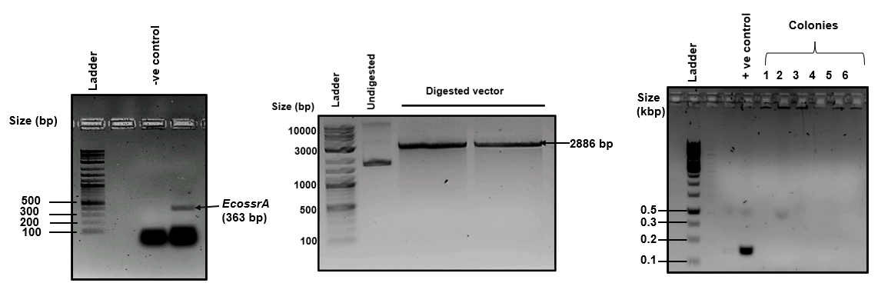

**Figure 9. (A) Agarose Gel Electrophoresis (1.5% gel) of PCR Amplicon:** Amplification of ssrA gene of E. coli from its genomic DNA **(B) Restriction digestion of cloning transcription vector pTZ57R/T:** Digested pTZ57R/T_CRISPR_sense run on 1.5% agarose gel.  **(C) Clone confirmation by culture PCR:** 1.5% Agarose gel analysis of clones obtained from culture PCR from transformed colonies of E. coli DH5α with pTZ57R/T-EcossrA plasmid.

## Overexpression and purification of AlaRS protein in *E. coli* JM109

*E. coli* JM109 cells containing the plasmid pQE30-his-AlaRS were treated with 1 mM IPTG to induce overexpression of the AlaRS protein. Cell lysates from both IPTG-induced and uninduced cultures were analyzed using 10% SDS-PAGE to assess AlaRS protein expression. A 98 kDa band, corresponding to the AlaRS protein, was detected in the induced sample.

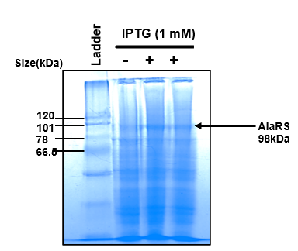

**Figure 10. Overexpressing of AlaRS:** Coomassie Blue stained 10% SDS-PAGE showing the resolved protein lysates of E. coli JM109 cells after induction with (+) and without (-) IPTG (1 mM).

The AlaRS protein was purified using Ni²⁺-NTA affinity chromatography as mentioned in [*Guyomar et* al*.,2020*](https://pmc.ncbi.nlm.nih.gov/articles/PMC8522692/). Soluble fraction was allowed to bind to Ni²⁺-NTA beads after sonication. The bound protein was then eluted using 500 mM imidazole, and elutes were analysed on 10% SDS-PAGE. A band of size 98 kDa corresponding to the elutes of AlaRS protein was observed. The purified AlaRS protein was finally buffer-exchanged into a storage buffer composed of Tris 25 mM (pH 8.0), NaCl 150 mM, glycerol 10% and then concentrated for further use.

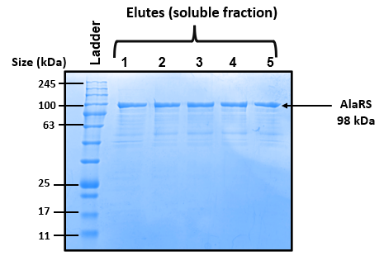

**Figure 11. Purification of AlaRS protein using Ni+2-NTA affinity chromatography:** 10% SDS-PAGE analysis of elutes (1-5) stained with Coomassie Brilliant Blue showing the presence of 98 kDa band that corresponds to AlaRS protein.

## Purification of LinSmpB protein

*E. coli* BL21 cells containing the *smpB* gene cloned in plasmid pET-23a were treated with 1 mM IPTG to induce overexpression of the SmpB protein. Purification of the recombinant LinSmpB protein was carried out under native conditions using a Ni²⁺-NTA affinity chromatography system. The induced cells were lysed with a native lysis buffer and subjected to sonication. Soluble fraction was allowed to bind to Ni²⁺-NTA beads. LinSmpB was subsequently eluted using an elution buffer containing 250 mM imidazole, and the eluted fractions, were assessed on 12% SDS-PAGE (Fig. 8B). A band of size 18 kDa corresponding to the elutes of LinSmpB protein was observed.

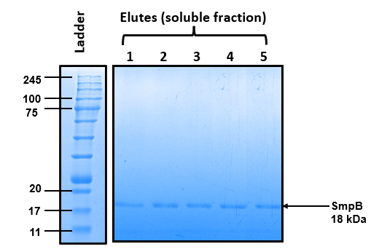

**Figure 12. Purification of SmpB protein using Ni+2-NTA affinity chromatography:** 12% SDS-PAGE analysis of elutes (1-5) stained with Coomassie Brilliant Blue showing the presence of 18 kDa band that corresponds to SmpB protein.

## Sanger Sequencing Verification of mutated pTZ57R/T_LinssrA

Plasmid vector pTZ57R/T containing LinssrA was mutated to replace MLD region of LinssrA with GFP11 by site directed mutagenesis using Q5 Site Directed Mutagenesis Kit by NEB. The PCR product was treated with KLD reaction (Kinase-Ligase-DpnI)) for 20 mins to eliminate the wild type DNA. Then 5µl of the mixture was transformed into DH5α cells and plated on LB agar plate containing Ampicillin and grown overnight at 37ᵒC. Few colonies were picked and further processed for Sanger Sequencing.

Pairwise sequence alignment was done using EMBOSS Needle between the Sanger sequencing chromatogram-derived sequence and the reference LinssrA gene cloned in pTZ57R/T. Matching bases are indicated by vertical bars, while mismatches and gaps reveal discrepancies between the experimental and reference sequences. Sequence 1 represents the sequence obtained from forward primer sequencing results whereas Sequence 2 represents LinssrA gene sequence.

Red dotted marked portion was supposed to be replaced by sfGFP’s 11th beta strand sequence (GCACGTGACCACATGGTCCTTCATGAGTACGTAAATGCTGCTGGGATTACATAA). However not even the original LinssrA gene could be detected in the sequencing results.

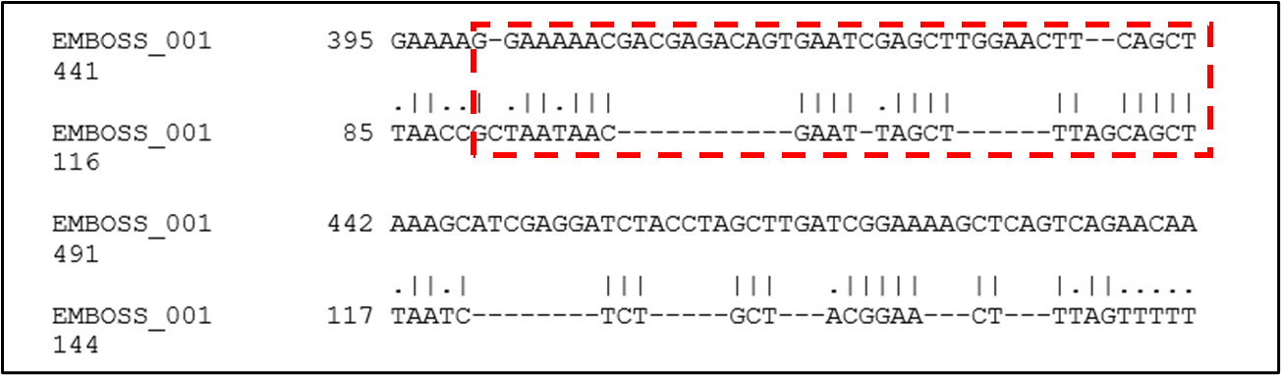

**Figure 13.** Pairwise alignment of Sanger sequencing result with the reference LinssrA gene sequence.

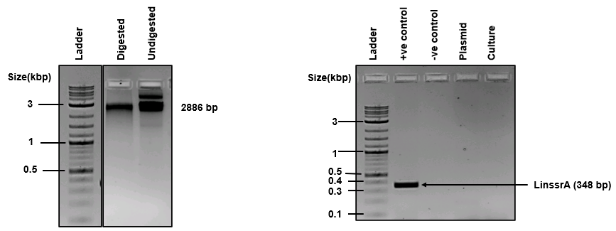

**(A)**

**(B)**

**Figure 14**. **Further confirmation of false mutation** by **(A)** restriction digestion: Digested pTZ57R/T_LinssrA run on 1.0% agarose gel. **(B)** Culture PCR and Plasmid PCR: Plasmid pTZ57R/T_LinssrA and culture containing the plasmid was amplified along with genomic DNA of L. interrogans.

Absence of LinssrA in pTZ57R/T vector was further confirmed by restriction digestion to check for fallout of LinssrA gene at 348 bp and Culture PCR and Plasmid PCR to check for amplified LinssrA gene at 348 bp. No fallout was observed after restriction digestion with *HindIII* and *KpnI* for 2 hours. Absence of bands in Culture PCR and Plasmid PCR further confirmed that the LinssrA gene was not cloned successfully previously.

## Re-cloning of *ssrA* gene of *L. interrogans* in vector pTZ57R/T

The *ssrA* gene was amplified from genomic DNA of *L. interrogans* serovar Copenhageni strain Fiocruz L1-30 by Polymerase Chain Reaction using Taq polymerase with specifically designed forward and reverse primers. The amplification of the *ssrA* gene (348 bp) was observed (Fig.9A). The purified insert and vector were double digested with restriction enzymes *HindIII* and *KpnI*. The double-digested products, i.e., vector and insert, were ligated and transformed into *E. coli* DH5α competent cells. The transformants obtained were screened using culture PCR (Fig.13). An amplicon of size 348 bp was obtained from clones 1-12.

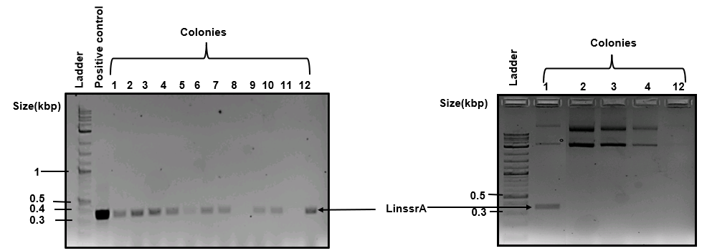

**(A)**

**(B)**

**Figure 15**. **Cloning confirmation of ssrA gene of L. interrogans (A) culture PCR:** 1.5% Agarose gel analysis of clones(1-12) obtained from culture PCR from transformed colonies of E. coli DH5α with pTZ57R/T-LinssrA plasmid. **(B) Plasmid PCR:** Further, clone confirmation of colonies(1-4,12) by plasmid PCR.

# Conclusion

* Site directed mutagenesis of LinssrA was performed to replace the internal MLD region with sfGFP’s 11th beta strand. However, Sanger Sequencing confirmed that the mutation did not happen.
* The sequence obtained from Sanger sequencing appears to be primarily from the cloning vector backbone rather than gene of interest which implies the gene of interest *ssrA* was not successfully cloned in the pTZ57R/T transcription vector.
* Re-cloning of LinssrA gene was done in pTZ57R/T transcription vector between *HindIII* and *KpnI* sites and confirmed via Culture PCR and Plasmid PCR. However further confirmation is to be done by sequencing and restriction digestion before proceeding with mutation.
* The process of overexpressing, purifying, and buffer-exchanging of AlaRS protein resulted in a yield of 0.44 milligrams per liter.
* LinSmpB was purified successfully with a yield of 1.54 mg/L to be used further for in vitro assay.

# References

1. Ame, M. M. (2021). Review on Leptospirosis and its Public Health Significance.
2. Bharti, A. R.; Nally, J. E.; Ricaldi, J. N.; Matthias, M. A.; Diaz, M. M.; Lovett, M. A.; Levett, P. N.; Gilman, R. H.; Willig, M. R.; Gotuzzo, E., Leptospirosis: a zoonotic disease of global importance. The Lancet infectious diseases 2003, 3, 757-771.
3. Cabantous, S., & Waldo, G. S. (2006). In vivo and in vitro protein solubility assays using split GFP. Nature methods, 3(10), 845-854.
4. Cabantous, S., Terwilliger, T. C., & Waldo, G. S. (2005). Protein tagging and detection with engineered self-assembling fragments of green fluorescent protein. Nature biotechnology, 23(1), 102-107.
5. Cronan, G. E.; Kuzminov, A., Degron-controlled protein degradation in Escherichia coli: New Approaches and Parameters. ACS Synthetic Biology 2024.
6. d’Urso, G.; Guyomar, C.; Chat, S.; Giudice, E.; Gillet, R., Insights into the ribosomal trans‐translation rescue system: lessons from recent structural studies. The FEBS Journal 2023, 290, 1461-1472.
7. Dong, G.; Nowakowski, J.; Hoffman, D. W., Structure of small protein B: the protein component of the tmRNA–SmpB system for ribosome rescue. The EMBO journal 2002, 21, 1845- 1854.
8. Evangelista, K. V.; Coburn, J., Leptospira as an emerging pathogen: a review of its biology, pathogenesis and host immune responses. Future microbiology 2010, 5, 1413-1425.
9. Gayathri, R., Archana, V., & Ramya, M. (2022). Molecular Diagnostic Methods for the Detection of Leptospirosis. Journal of Pure & Applied Microbiology, 16(2).
10. Giudice, E.; Macé, K.; Gillet, R., Trans-translation exposed: understanding the structures and functions of tmRNA-SmpB. Frontiers in Microbiology 2014, 5, 113.
11. Goarant, C., Trueba, G., Bierque, E., Thibeaux, R., Davis, B., & de La Pena-Moctezuma, A. (2019). Leptospira and leptospirosis. *Water and Sanitation for the 21st Century: Health and Microbiological Aspects of Excreta and Wastewater Management (Global Water Pathogen Project)*.
12. Guyomar, C., Thépaut, M., Nonin-Lecomte, S., Méreau, A., Goude, R., & Gillet, R. (2020). Reassembling green fluorescent protein for in vitro evaluation of trans-translation. Nucleic Acids Research, 48(4), e22-e22.
13. Haake, D. A.; Levett, P. N., Leptospira species (leptospirosis). In Mandell, Douglas, and Bennett's Principles and Practice of Infectious Diseases, Elsevier: 2015; pp 2714-2720. e2.
14. Hopper, A. K., & Shaheen, H. H. (2008). A decade of surprises for tRNA nuclear–cytoplasmic dynamics. Trends in cell biology, 18(3), 98-104.
15. Ibba, M., & Söll, A. D. (1999). Quality control mechanisms during translation. Science, 286(5446), 1893-1897.
16. Karzai, A. W.; Susskind, M. M.; Sauer, R. T., SmpB, a unique RNA-binding protein essential for the peptide-tagging activity of SsrA (tmRNA). The EMBO journal 1999, 18, 3793- 3799.
17. Keiler, K. C. (2008). Biology of trans-translation. *Annu. Rev. Microbiol.*, *62*(1), 133-151.
18. KoMINE, Y.; Kitabatake, M.; Yokogawa, T.; Nishikawa, K.; Inokuchi, H., A tRNA-like structure is present in 10Sa RNA, a small stable RNA from Escherichia coli. Proceedings of the National Academy of Sciences 1994, 91, 9223-9227.
19. Liang, X.; Cheng, A.; Ma, C.; Gao, N., Bacterial protein synthesis. In Molecular Medical Microbiology, Elsevier: 2024; pp 257-275.
20. Moore, S. D.; Sauer, R. T., The tmRNA system for translational surveillance and ribosome rescue. Annu. Rev. Biochem. 2007, 76, 101-124.

Nucleic acids research 2003, 31, 446-447.

1. Pédelacq, J. D., Cabantous, S., Tran, T., Terwilliger, T. C., & Waldo, G. S. (2006). Engineering and characterization of a superfolder green fluorescent protein. Nature biotechnology, 24(1), 79-88.
2. Püllmann, P., Knorrscheidt, A., Münch, J., Palme, P. R., Hoehenwarter, W., Marillonnet, S., ... & Weissenborn, M. J. (2021). A modular two yeast species secretion system for the production and preparative application of unspecific peroxygenases. Communications biology, 4(1), 562.
3. Svetlov, M. S. (2021). Ribosome-associated quality control in bacteria. *Biochemistry (Moscow)*, *86*, 942-951.
4. Thépaut, M., Campos-Silva, R., Renard, E., Barloy-Hubler, F., Ennifar, E., Boujard, D., & Gillet, R. (2021). Safe and easy in vitro evaluation of tmRNA-SmpB-mediated trans-translation from ESKAPE pathogenic bacteria. RNA, 27(11), 1390-1399.
5. Xiong, Y., & Steitz, T. A. (2006). A story with a good ending: tRNA 3′-end maturation by CCA-adding enzymes. Current opinion in structural biology, 16(1), 12-17.
6. Zwieb, C.; Gorodkin, J.; Knudsen, B.; Burks, J.; Wower, J., tmRDB (tmRNA database).